Project Design Phase-II
Data Flow Diagram & User Stories

Date | 15 July 2026
Team ID
Project Name | Food Ordering Behaviour and Consumer Trends
Maximum Marks | 4 Marks

Data Flow Diagrams:
A Data Flow Diagram (DFD) is a traditional visual representation of the information flows within a system. A neat and clear DFD can depict the right amount of the system requirement graphically. It shows how data enters and leaves the system, what changes the information, and where data is stored.
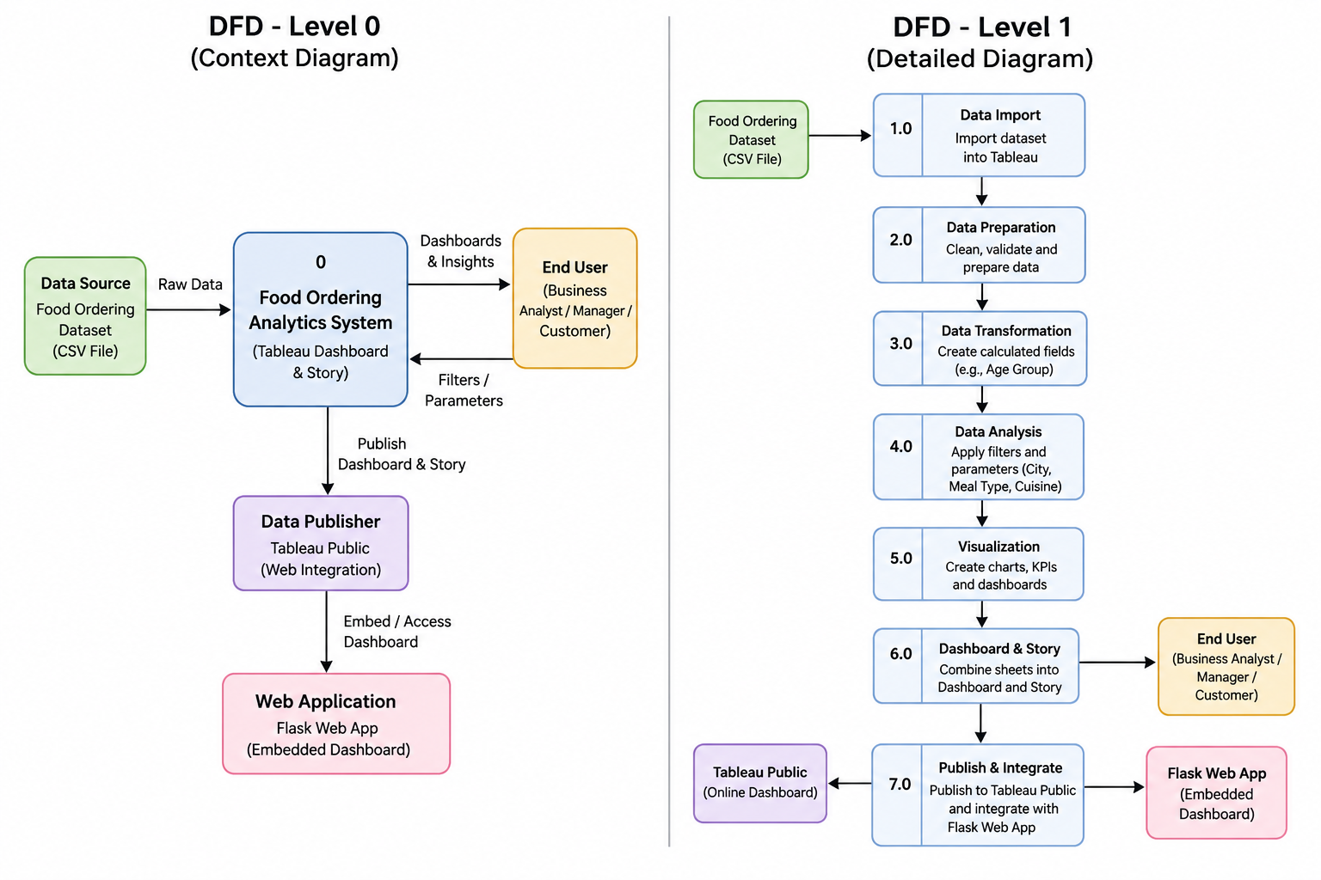
User Stories

User Type | Functional Requirement (Epic) | User Story Number | User Story / Task | Acceptance criteria | Priority | Release
Business Analyst | Dashboard | USN-1 | As a Business Analyst, I want to analyze order trends so that I can identify customer behaviour. | Dashboard displays accurate order trends. | High | Sprint-1
Business Analyst | KPI Analysis | USN-2 | As a Business Analyst, I want to monitor KPIs to evaluate business performance. | KPIs update correctly. | High | Sprint-1
Operations Manager | Delivery Analysis | USN-3 | As an Operations Manager, I want to analyze delivery times to improve efficiency. | Delivery charts display correctly. | High | Sprint-1
Operations Manager | City Analysis | USN-4 | As an Operations Manager, I want to compare city-wise orders. | City filter works properly. | Medium | Sprint-2
Customer | Cuisine Analysis | USN-5 | As a customer, I want to view popular cuisines so I can understand food trends. | Cuisine charts load correctly. | Medium | Sprint-2
Customer | Meal Type | USN-6 | As a customer, I want to explore meal preferences by breakfast, lunch, dinner, and snacks. | Meal-type visualization displays correctly. | Medium | Sprint-2
Administrator | Data Management | USN-7 | As an administrator, I want to update datasets for dashboard analysis. | Dataset refreshes successfully. | High | Sprint-1
Administrator | Report Publishing | USN-8 | As an administrator, I want to publish dashboards to Tableau Public. | Dashboard is published successfully. | Medium | Sprint-2
Business Analyst | Story | USN-9 | As a Business Analyst, I want to create an interactive story that summarizes insights. | Story navigation works correctly. | High | Sprint-2
Administrator | Dashboard Filters | USN-10 | As an administrator, I want to manage filters for interactive analysis. | Filters work without errors. | Medium | Sprint-2

